

BAŞKENT UNIVERSITY
ELECTRIC & ELECTRONICS ENGINEERING

EEM 214 ~ ELECTRONICS–I
LABORATORY
PRELIMINARY WORK

Experiment Name : Diode Rectifier Circuits
Experiment Number : 4

Student Name : Buğra BAYRAM
Student Number : 20193272
Section Number : | Experiment Day:

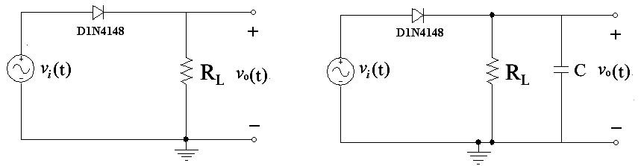
2)
a)

v_{i}(t)=5sin(200πt),
our output and input waveform
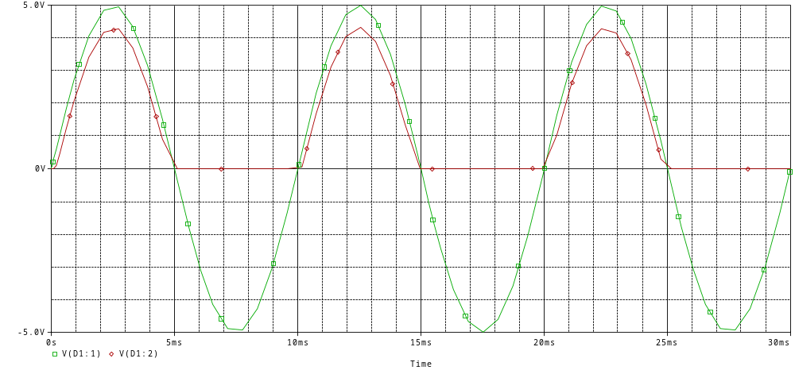
i/p - o/p

Current of diode
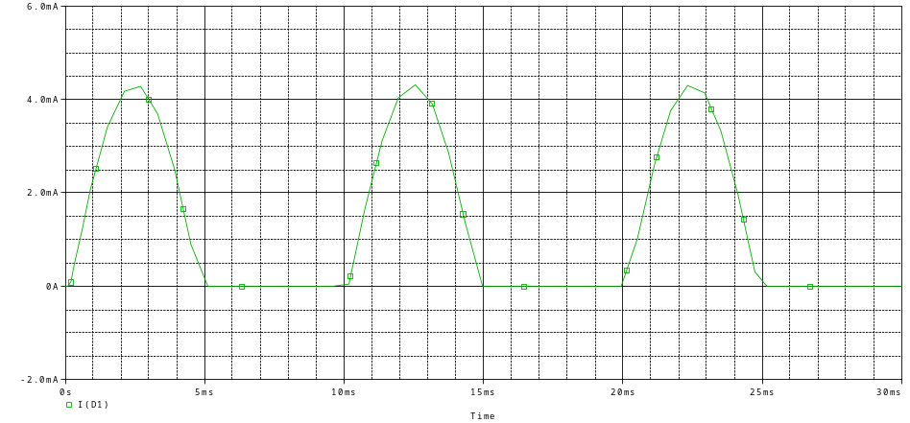
Current 1

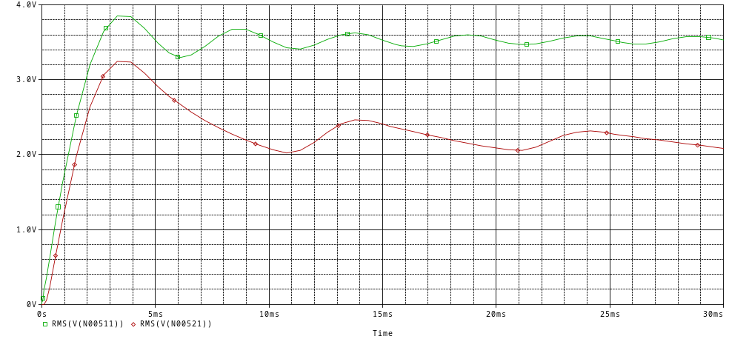
Rms 1
b)

v_{i}(t)=5sin(200πt)
our output and input waveform
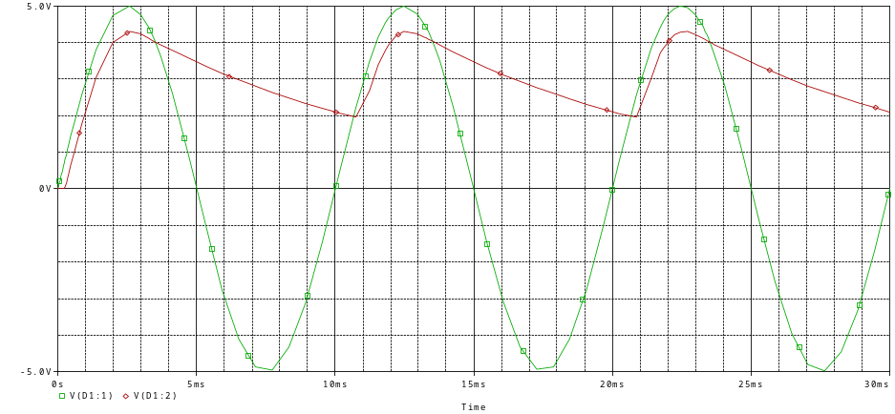
i/p - o/p

Current of diode
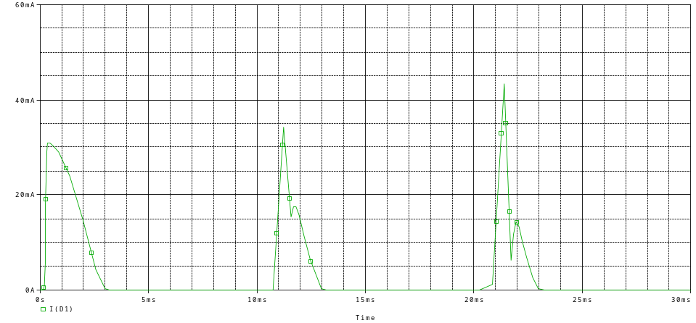
Current 2
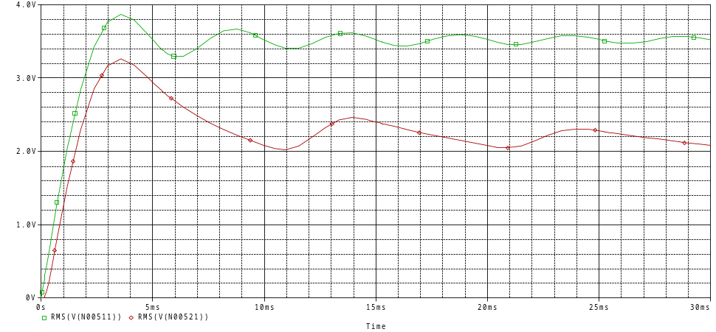
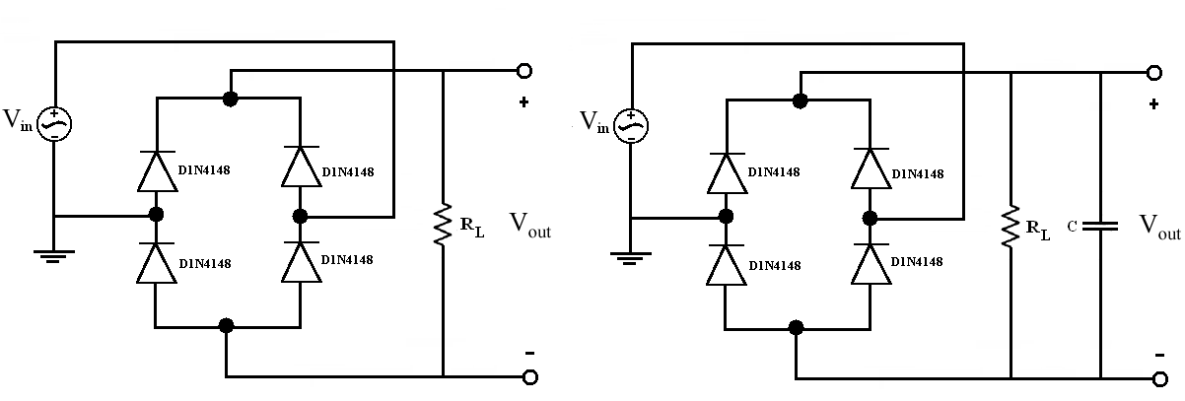
Rms 2

- a)

v_{i}(t)=5sin(200πt)
our output and input waveform
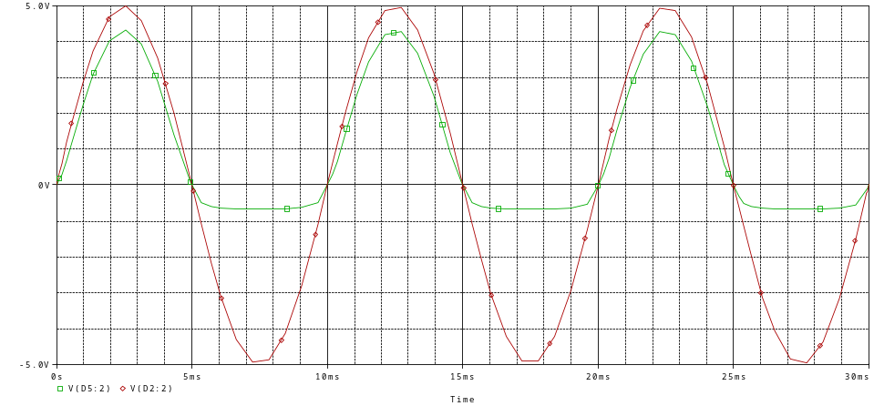
i/p - o/p

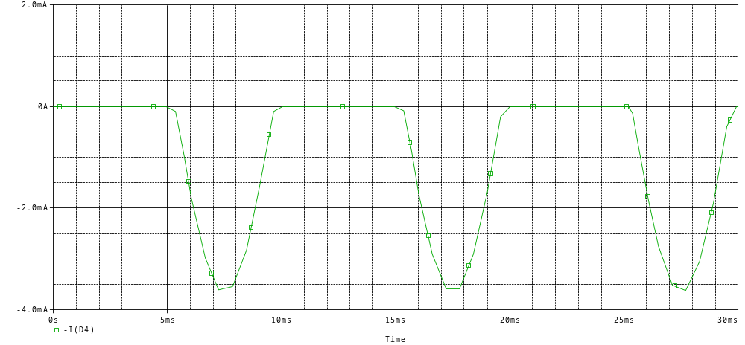
Current 3

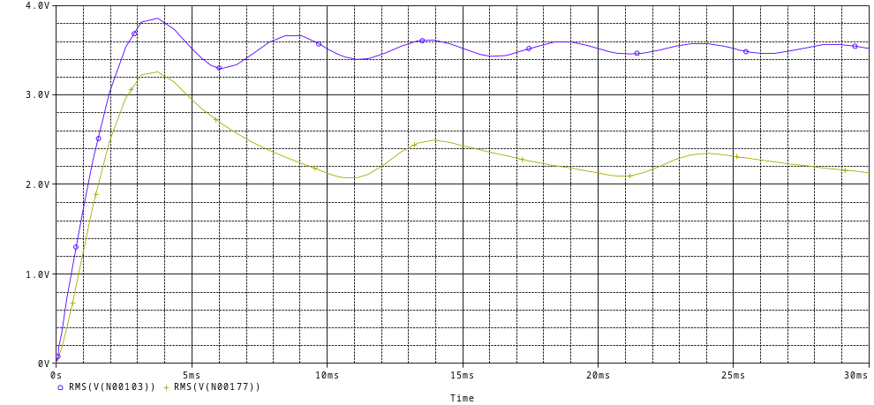
Rms 3
b)

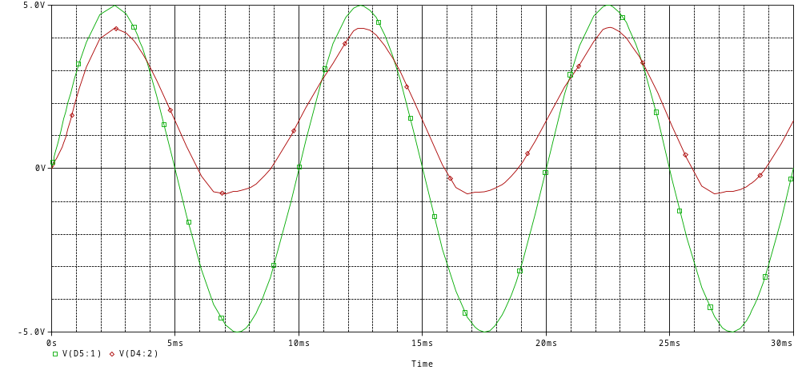
i/p - o/p
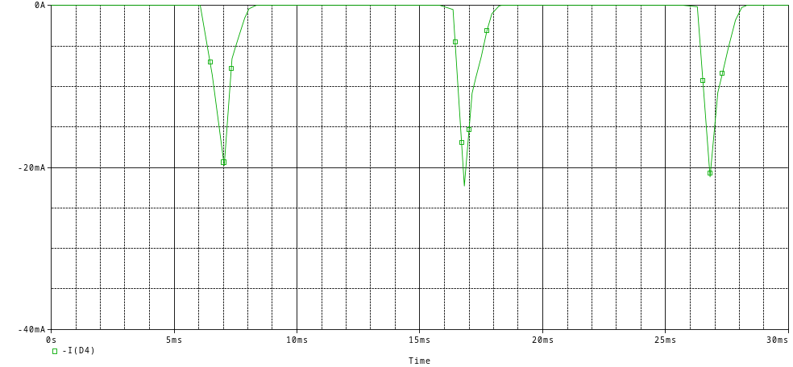
Current 4
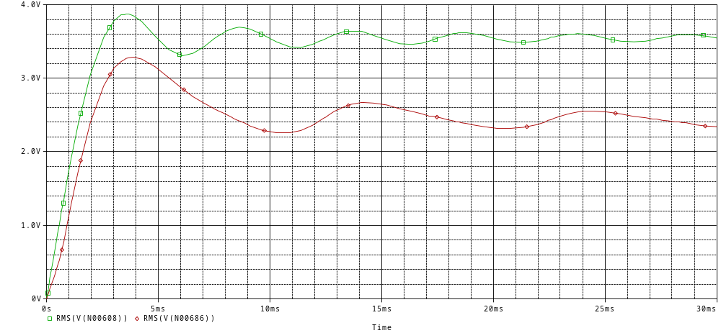
Rms 4

